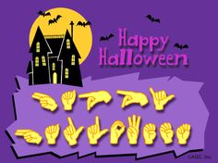
Today is a day of spooky

More ASL Signs of Halloween
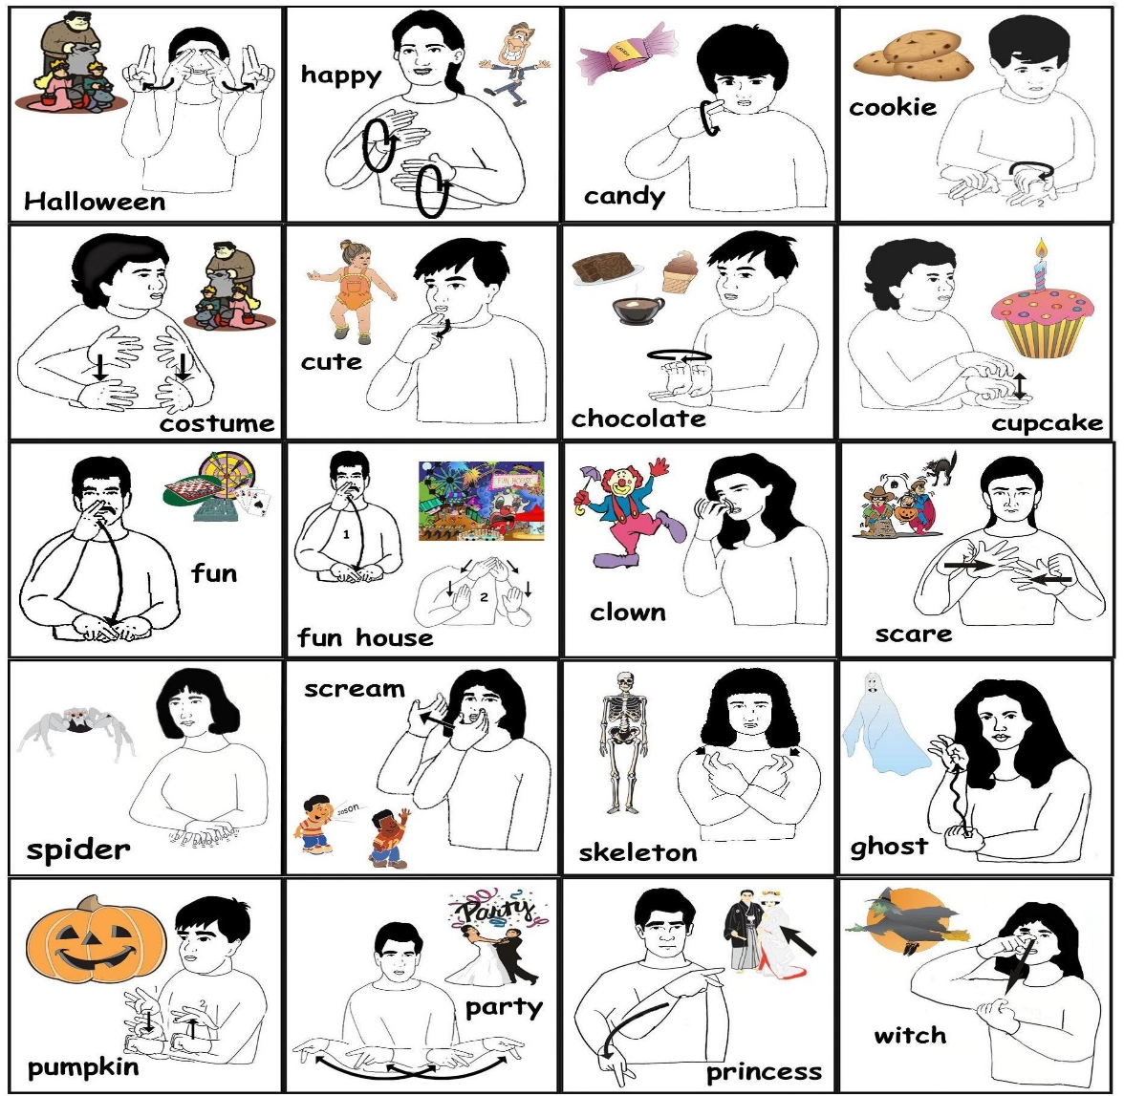

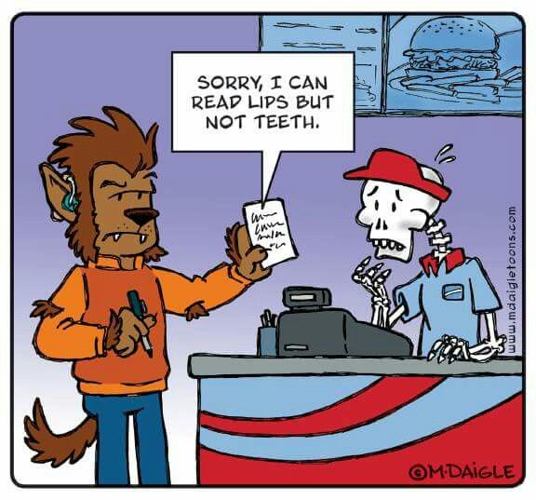
Enjoy your day! Don’t forget to brush your teach when you’re all done eating candy. Wink!

Your teacher … has become … a zombie!

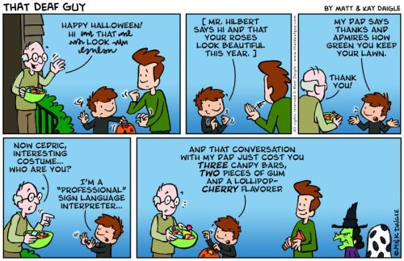

Did it scare ya?! Darn.
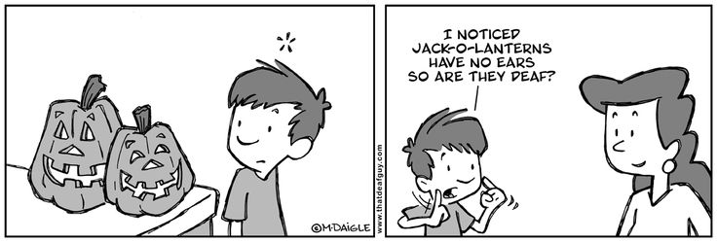
Oh well, have a great day today. It’s been a treat teaching you ASL. Keep it up and I’ll see you at the next class!
From your crazy teacher, Jodi Anicello,

