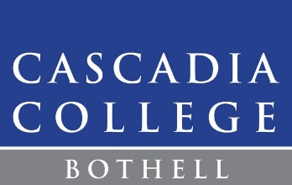

**Bachelor of Applied Science – Mobile Application Development**

**Guaranteed Admissions**

Cascadia College’s guaranteed admissions program is for students who are currently enrolled in an associate’s degree program and interested in the Bachelor of Applied Science Degree in Mobile Application Development.

Students meeting the guaranteed admissions criteria will receive initial notification of their eligibility to apply for the program by the Information Technology Programs Advisor. These students will still be required to complete the application for admissions to the Bachelor of Applied Science program in order to be officially admitted.

**Guaranteed Admissions Requirements**

* Completion of English 101 with a 2.0 or higher GPA
* Completion of BIT 142 with a 2.5 or higher GPA
* Plan to complete BIT 143 by the summer quarter before their planned cohort begins
* Completion of at least 90 credits of college-level coursework by their cohort start date

**Admissions Process**

* Eligible students will be contacted by the Information Technology Programs Advisor
* Students will be encouraged to meet with the IT advisor for a transfer and admissions advising meeting
* Interested students will be required to complete the application for admissions to the BAS Mobile Application Development in order to be officially admitted
* The priority application deadline will continue to be taken into consideration with application submissions