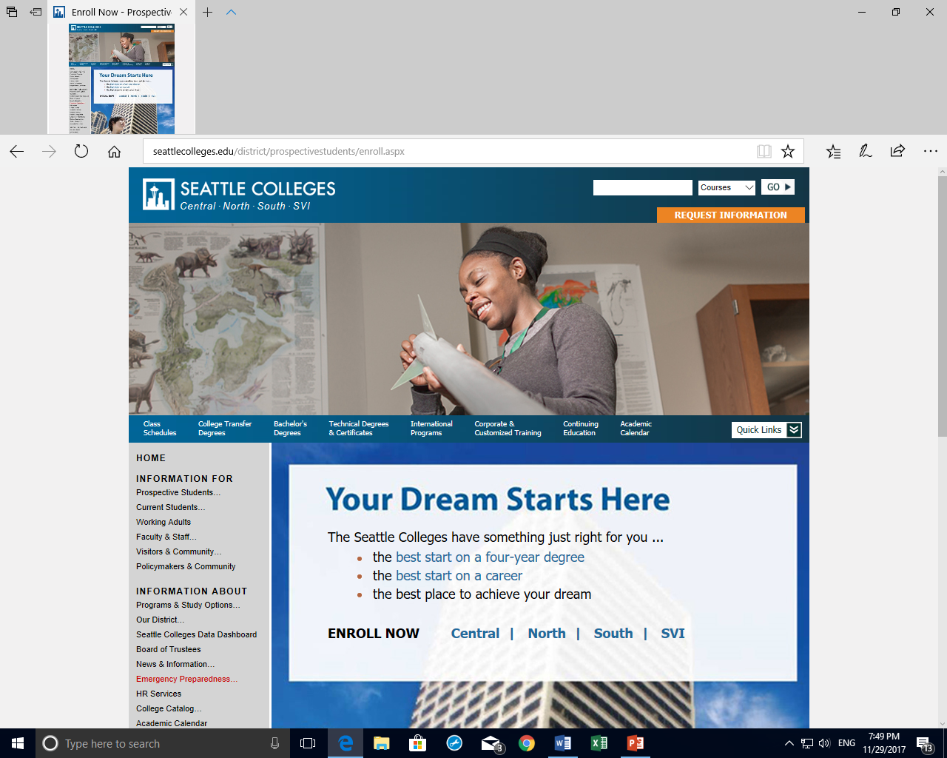



**District Faculty Development**

**Winter 2021 Professional Development Event**

You are cordially invited to participate in the upcoming district-wide online PD workshop



How to Make PLA Work for your Program

Introduction to Prior Learning Assessment and Its Benefits

**Facilitated by**

**Wilson Finch, VP Consulting,**

**The Council for Adult and Experiential Learning (CAEL)**

**Wednesday, March 3rd, 2021, 1:00-2:30pm**

While it has been around for many decades, PLA has been an increasingly utilized tool to help adult learners access and succeed in higher education.  This webinar will introduce the concepts behind PLA, what it includes and does not include, the latest national research concerning its outcomes for students and institutions, and how South Seattle is enhancing and improving its PLA program in two degrees.

**Presenter:**

The Council for Adult and Experiential Learning (CAEL) was founded to help organizations succeed by providing expertise, resources, and solutions that effectively support adult learners as they navigate on- and off-ramps between education and employment. We partner with entities across the adult learner ecosystem to help create actionable career pathways along the journey of lifelong learning and meaningful work.

**Recent PLA Research:**

[https://www.cael.org/news-and-resources/new-research-from-cael-and-wiche-on-prior-learning-assessment-and-adult-student-outcomes](https://nam04.safelinks.protection.outlook.com/?url=https%3A%2F%2Fwww.cael.org%2Fnews-and-resources%2Fnew-research-from-cael-and-wiche-on-prior-learning-assessment-and-adult-student-outcomes&data=04%7C01%7C%7C314b2c4d428f4a77b5d608d8be327897%7C02d8ff38d7114e31a9156cb5cff788df%7C0%7C0%7C637468471262267428%7CUnknown%7CTWFpbGZsb3d8eyJWIjoiMC4wLjAwMDAiLCJQIjoiV2luMzIiLCJBTiI6Ik1haWwiLCJXVCI6Mn0%3D%7C1000&sdata=WGFRO2SUNKDD9SNtbXEOpA61q71ZDzvAU202azJiZ14%3D&reserved=0)

**Please mark your calendar and be there!**

For more information, please contact Judy Reed, Grant manager/MOET Advisor at [judy.reed@seattlecolleges.edu](mailto:judy.reed@seattlecolleges.edu), or Yilin Sun, District Faculty Development at FD@seattlecolleges.edu