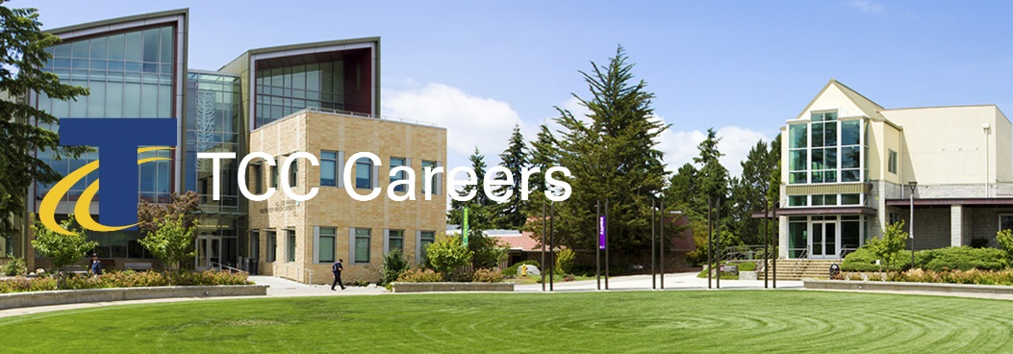 | We invite you to join us and be an active part of a multicultural environment dedicated to academic excellence.  Posting Date: February 27, 2019 Priority Date: March 31, 2019  Announcement: 19-05-AP #MON  Create Learning / Achieve Equity  Engage Community / Embrace Discovery

Provost & Vice President of Academic Affairs

Priority Consideration Date: March 31, 2019

Tacoma Community College
Since opening its doors in 1965, TCC has provided a high-quality, affordable education to more than 500,000 people. Serving Tacoma, Gig Harbor, the Key Peninsula, online students and the women’s prisons, TCC educates about 11,000 students annually. Many TCC students are the first in their families to attend college, 58 percent receive financial aid, 13 percent have children, 42 percent are students of color, and 48 percent work while attending school.

Divided into 4 academic divisions (Arts, Humanities & Social Sciences; Health, Business & Professional Programs; Math, Science & Engineering; Communication & Transitional Studies) TCC is committed to developing and sustaining a vibrant educational environment where all students can thrive by providing educational opportunities such as learning communities, honors programming, undergraduate student research, bachelor of applied science degrees, and study abroad.

TCC is 100 percent committed to student success, and promotes innovation to help students. Since launching its Open Educational Resources initiative in 2011, the college has saved students collectively more than $5 million on textbooks. Designated an Achieving the Dream Leader College, TCC provides a model for other schools seeking to engage students and boost completion rates. TCC is also one of 67 colleges selected nationally to participate in the Department of Education’s Second Chance Pell pilot program, providing access to education for incarcerated individuals. Designated a Military Friendly College®, TCC is proud to serve Pierce County’s military community. In fall 2018, the college opened a food pantry on campus to support students experiencing food insecurity and was recognized by the Harvard Kennedy School for its College Housing Assistance Program, a community partnership that helps students access affordable housing.

Led by President Dr. Ivan Harrell, who joined the college in the spring of 2018, the college community is currently engaged in strategic planning to increase enrollment, retention and completion while ensuring that TCC is well positioned to continue serving the local community in the decades to come.

Ideal Characteristics
The successful candidate for this position is an experienced leader with a clear, focused commitment to teaching, learning and academic excellence to promote student success. This candidate is a creative, visionary leader who will inspire staff, students and the community with the ability to create and maintain strong relationships and build trust and consensus with college and community constituents. The candidate is an innovative thinker who seeks innovative solutions to problem solving and is a critical thinker with outstanding interpersonal, written and oral communication skills with a dedication towards transparency. The candidate is highly ethical, trustworthy, credible, loyal, and is respectful of diverse views and opinions with a commitment to intentional institutional work in equity, diversity, and inclusion. The candidate is flexible and inter-culturally competent and is a person whose leadership style is collegial, approachable, and accessible on campus and in the community. The candidate is able to delegate responsibility and authority while maintaining accountability. This seasoned professional fosters cohesion and a sense of working together for the good of the College and is committed to the effective use of technology within academic and administrative environments while keeping a focus on the importance of sustainability at places of higher education.

Responsibilities
The Provost & VP of Academic Affairs (VPAA) serves as the chief academic officer of the college, providing vision and leadership for the overall educational program of the college. Reporting to the college president the Provost & VPAA serves as the second-in-command of the college, and in absence of the President, serves in that role. The Provost & VPAA has primary leadership responsibilities for planning, implementing, and coordinating an effective and inclusive academic program. The Provost & VPAA works closely with academic deans, faculty, and other members of the administration to address educational policy, instructional planning, program review, academic personnel actions, resource planning and allocation and faculty development. As part of the college’s executive cabinet, the Provost & VPAA will work with the president and other vice presidents to provide overall leadership for the college’s enrollment, student success and retention efforts, equity, diversity and inclusion, and Guided Pathways efforts.

The Provost & VPAA will provide direct leadership over the following areas of the college:
- Academic Divisions
  - Arts, Humanities & Social Sciences
  - Communication & Transitional Studies
  - Health, Business & Professional Programs
  - Math, Science & Engineering
- Bachelors of Applied Science Degrees
- Corrections Education
- eLearning
- Library
- Learning Communities
- Honors Program
- Workforce Education

The Provost & VPAA will:
- Develop and maintain an effective and relevant academic programs that address community and student needs.
- Identifies curricular needs and approaches for improvement and innovation of culturally sustaining curriculum. Supports curriculum development and flexibility of instructional delivery.
- Works with the Vice President of Equity, Diversity & Inclusion, and the college as a whole, to identify and ensure equitable outcomes related to student achievement and the recruitment and retention of faculty and staff of color.
- Promotes instructional innovation through leadership in evidence-based approaches to improving student success and completion.
- Ensures high quality academic and workforce programs.
- Ensure equity in instruction and access to services for online students.
- Works to ensure access to TCC education for current and previously incarcerated students in populations served by TCC.
- Assists faculty in the use of data to improve instructional effectiveness.
- Leads the coordination of class schedules, the college catalog, and other instructional publications.
- Oversees the academic program review and evaluation process, which includes the use of data to identify and address areas of improvement.
- Provides leadership regarding college initiatives
- Works with the Vice President of Student Affairs to ensure collaboration of academic and student services to provide appropriate resources and support for the student body.
- Assures availability and coordination of instructional support systems through the coordination of learning resource services and instructional and student support technology.
- Provide leadership in support of the Library’s mission and goals.
- Provides support for the promotion of Open Educational Resources under the direction of elearning and the Library.
- Works with the Division of Organizational Learning & Effectiveness to provide needed faculty development opportunities
- Appropriately addresses issues related to faculty hiring, recruitment and evaluation, in conjunction with Human Resources and the faculty union.
- Recommends candidates for faculty and administrative positions to the college President.
- Oversees the faculty tenure and post-tenure review processes.
- Supervises, evaluates and develops appropriate professional development plans for all direct reports.
- Works to strengthen articulation and collaboration with K-12 systems, other colleges and universities, public agencies, and businesses and industry partners.
- Actively participates in college, State Board, and community committees, councils and organizations.
- Maintains and fosters positive relations with the State Board for Community and Technical Colleges (SBCTC) and other governing bodies such as the Northwest Commission on Colleges and Universities (NWCCU)
- Oversees the development and management of appropriate budgets, including prioritization of funding to align with the college’s mission and strategic objectives.
- Provides leadership in the continued and improved usage of People Soft/ctcLink and Civitas Learning to increase student success and retention.
- Provides for the acquisition and maintenance of instructional equipment by developing, operating, and monitoring an equitable and sustainable purchase and maintenance plan.
- Acts on behalf of the president, and assumes responsibility of the college in the absence of the president, or at his discretion.
- Other duties as assigned.
Qualifications for the Provost & Vice President of Academic Affairs
Minimum Qualifications
- Master’s degree from an accredited institution.
- Teaching Experience.
- Minimum of 5 years of senior level academic administrative experience in higher education.
Preferred Qualifications
- Doctoral degree.
- Community college experience.
- Experience as a faculty lead, department chair or dean.
- Experience working in unionized environments.
- Experience and leadership in serving, advocating for, collaborating with, and representing underrepresented and marginalized communities.
- Experience creating equitable, inclusive and responsive academic programming.
Conditions of Employment
- Successfully complete a criminal history background check.
Application Process
Complete application packages must include the following:
- Tacoma Community College online application.
- Resume & cover letter describing how your educational background and experience align with the responsibilities and qualifications.
- Copies of transcripts for all colleges and universities attended.
- Tacoma Community College is committed to creating and supporting a multi-cultural climate that welcomes, fosters, respects, and celebrates diversity. Please attach a statement (maximum two pages) describing your experiences with other cultures and communities, your level of cultural self-awareness and how you have integrated both experience and self-awareness into your living/working environment.

Terms of Employment
This is full-time professional administrative position contracted on an annual basis. The salary range for this position is $135,000 to $150,000 annually DOE/DOQ. The salary will be prorated to reflect the actual number of contract days worked in the remainder of the fiscal year. Flexibility in scheduling is required to meet the needs of the department. The College offers a generous benefits package. Degrees must be from accredited colleges or universities recognized by the U.S. Department of Education and verified by National Student Clearinghouse.

Tacoma Community College provides equal opportunity in education and employment and does not discriminate on the basis of race, color, national origin, age, disability, genetic information, sex, sexual orientation, marital status, creed, religion, or status as a veteran of war. Prohibited sex discrimination includes sexual harassment (unwelcome sexual conduct of various types). Provides reasonable accommodations for qualified students, employees, and applicants with disabilities in accordance with the American with Disabilities Act and Federal Rehabilitation Act. The following persons have been designated to handle inquiries regarding non-discrimination policies: Stephen Smith, Title II and Title IX, 253-566-5055; Dolores Haugen, Section 504 Officer, 253-566-6090.
Tacoma Community College is a smoke-free/drug free environment. This recruitment announcement may not reflect the entire job description and can be change and or modified at any time.
Tacoma Community College
6501 S 19th St Bldg. 14, Tacoma WA 98466
www.tacomacc.edu/about/employment

