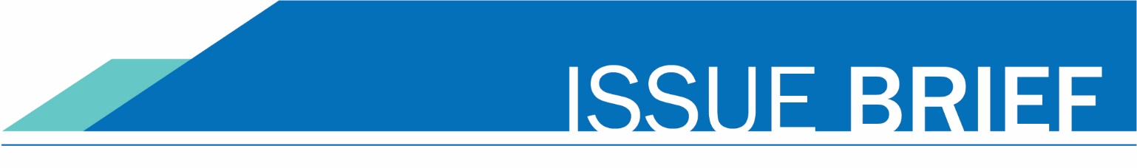
April 25, 2018

Strategic Enrollment Taskforce Update

Background
Washington state has set a goal through the Washington Student Achievement Council (WSAC) Road Map to achieve a 70 percent postsecondary attainment rate for adults. To meet this goal requires 380,000 new credential holders by 2023. The key strategies to accomplish this goal include closing the achievement gap for underrepresented students and postsecondary recruitment, retention, and completion, while addressing affordability issues.
Washington’s community and technical college system is well-positioned to play a major role in meeting this goal but has similar challenges compared to institutions across the nation with respect to retention and completion. Enrollment in the colleges has declined 21 percent in the past 15 years while tuition has doubled. Interestingly, full-time equivalent enrollments (FTES) have increased approximately seven percent in the same time period. This suggests a change in the population of adults who are coming to college now than at a time when enrollment was significantly higher. The number of high school graduates is flat and more of the recent graduates (traditional-aged students) are attending four-year institutions. Trends are clear that in order to meet the state’s goals it will require recruiting and engaging students who have not historically participated in higher education (e.g. adults with some college but no credential), and current conditions suggest this is a prime time to engage in a thoughtful strategic enrollment management plan.
During fall 2017, The Washington Association of Community and Technical Colleges (WACTC) authorized the WACTC Strategic Enrollment Taskforce be formed to build a stronger enrollment base for community and technical colleges. Over a two-year period, the taskforce was tasked with identifying state level and institutional strategies that will improve access and retention system-wide and incorporate those strategies into an adopted strategic enrollment workplan. The taskforce conducted monthly four-hour meetings beginning October 30, 2017 with feedback provided from councils and commissions throughout the process.
Participants in the taskforce include presidents from The Washington Association of Community and Technical Colleges (WACTC) and representation from WACTC commissions and other key system groups including instruction, student services, Chief Diversity and Equity Officers (CDEO), research and planning, public information, business affairs, information technology; faculty leadership (AFT, AHE, FACTC), and student groups. Additional college personnel participated as needed and partner stakeholders (K-12, community organizations, and workforce) were identified and considered for this work. SBCTC Education Division staff also participated.

Taskforce Goal
Over a 2-year period, the Task Force will identify state level and institutional strategies to employ to build a stronger enrollment foundation system-wide, and incorporate those strategies into a Strategic Enrollment Plan. Roles for the State Board, WACTC and its Commissions/Councils, and institutions will be clearly delineated. Strategic partners will be identified and engaged in the work.

Guiding Principles
The Taskforce adopted the following guided principles to guide the work:
- Equity – increasing enrollment and completion of students from underserved populations – is integral to the work of the taskforce
- We need to increase the number of students pursuing and completing a postsecondary credential, while minimizing competition between colleges in our system
- Outreach, onboarding, retention, and completion are key elements
- Our work will strengthen partnerships with K12, universities, employers, and community organizations
- The workplan will include system level and college level strategies, and will have clear prioritization

Statewide Targets
With a focus on increasing the number of students pursuing and completing a postsecondary credential, statewide targets were set in terms of the annual number of students enrolled in the system with the reported intent to complete a postsecondary credential (i.e., “award-seeking students”). The number of award-seeking students peaked during the 2010-11 school year (approximately 267,000) and then declined the last few years (approximately 249,000 in 2016-17). Based on current population trends, it is expected that the Washington community and technical colleges will experience a small increase in enrollment over the next five years followed by further declines. The targets shown in the chart below will require significant increases in rates of postsecondary participation and persistence with a focus on historically underserved populations. The targets also follow a trend of serving 5,000 more award-seeking students each year for the following five years. Across the 34 colleges, that is an average of 150 more award-seeking students per college each year. Serving more students includes more students new to the colleges and more students continuing to enroll until completion.

Final Recommendations
During the 2017-2018 academic year, the Taskforce reviewed data metrics, identified focus areas, determined goals/outcomes and finalized strategies that can be implemented in the community and technical college system during the 2018-2019 year two of the project. Called the Strategic Enrollment Taskforce Workplan, strategies were considered and prioritized based on the following criteria:

- Can the strategy be measured?
- Once implemented, how impactful will the strategy be? Will it significantly increase enrollment targets?
- Can the strategy be implemented during the 2018-2019 academic year?
- How many resources will be needed to implement? Is the cost prohibitive?
- Which student groups will be impacted? Does it support students from underserved populations?
- Does the strategy align with the taskforce guiding principles?

Recommendation #1
The Strategic Enrollment Taskforce recommends to WACTC that the attached workplan including focus areas, objectives, and strategies be adopted for implementation during the 2018-2019 academic year. The Strategic Enrollment Taskforce workplan is a “living document” with updates, minor revisions, and oversight monitored by the WACTC Education Services committee.

Recommendation #2
The Strategic Enrollment Taskforce recommends to WACTC that the statewide targets be adopted as a guideline for measuring the workplan objectives.

WACTC Strategic Enrollment Taskforce
2017-2018

 | Campus | Email
Presidents (Co-Chairs)
Jim Minkler | Grays Harbor | jim.minkler@ghc.edu
Suzanne Johnson | Green River | sjohnson@greenriver.edu
Chief Diversity & Equity Officers
Yvonne Terrell-Powell | Edmonds | yvonne.terrellpowell@edcc.edu
Business Affairs Commission
Bill Thomas | Lake Washington | bill.thomas@lwtech.edu
Kay Ash | Olympic | kash@olympic.edu
Faculty
Carlea McAvoy | SPSCC | cmcavoy@spscc.edu
Jaeney Hoene | Green River | jhoene@greenriver.edu
Sue Nightingale | Bellevue | sue.nightingale@bellevuecollege.edu
Information Technology Commission
Lori Casile | SPSCC | lcasile@spscc.edu
Mike Stocke | Pierce | mstocke@pierce.ctc.edu
Instruction Commission
Carli Schiffner | Wenatchee | cschiffner@wvc.edu
Tod Treat | Tacoma | ttreat@tacomacc.edu
Public Information Commission
Marisa Pierce | Edmonds | marisa.pierce@email.edcc.edu
Shawn Devine | Olympic | sdevine@olympic.edu
Research & Planning Commission
Allison Phayre | Olympic | aphayre@olympic.edu
Shanda Diehl | Clark | sdiehl@clark.edu
Student Services Commission
David Pelky | SPSCC | dpelkey@spscc.edu
Luca Lewis | Whatcom | llewis@whatcom.edu
Shirley Siloi | Tacoma | ssiloi@tacomacc.edu
Steve Ashpole | SPSCC | sashpole@spscc.edu
Students
Chloe Zabrek | Highline | chloezoe@gmail.com
Naol Debele | Edmonds | naol.debele@email.edcc.edu

SBCTC staff
Joyce Hammer | staff lead | jhammer@sbctc.edu
Autumn Yoke |  | ayoke@sbctc.edu
Cherie Berthon |  | cberthon@sbctc.edu
Darby Kaikkonen |  | dkaikkonen@sbctc.edu
Devin DuPree |  | devindupree@sbctc.edu
Jan Yoshiwara* |  | jyoshiwara@sbctc.edu
Joe Holliday |  | jholliday@sbctc.edu
Katie Rose |  | krose@sbctc.edu

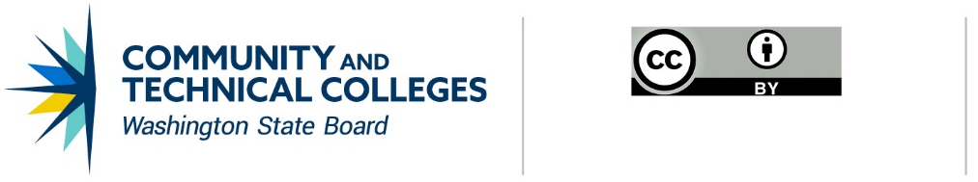
Note: All material licensed under CC BY.

CONTACT INFORMATION
Joyce Hammer
Director of Transfer
p: 360-704-4338
e: jhammer@sbctc.ed

http://www.wsac.wa.gov/strategic-action-plan
Dupree, D. (2015). CTC role in WSAC roadmap goals: Issue brief. Retrieved from https://www.sbctc.edu/colleges-staff/research/reports/socioeconomic-research.aspx
Education Research and Data Center High school feedback reports http://www.erdcdata.wa.gov/hsfb.aspx

