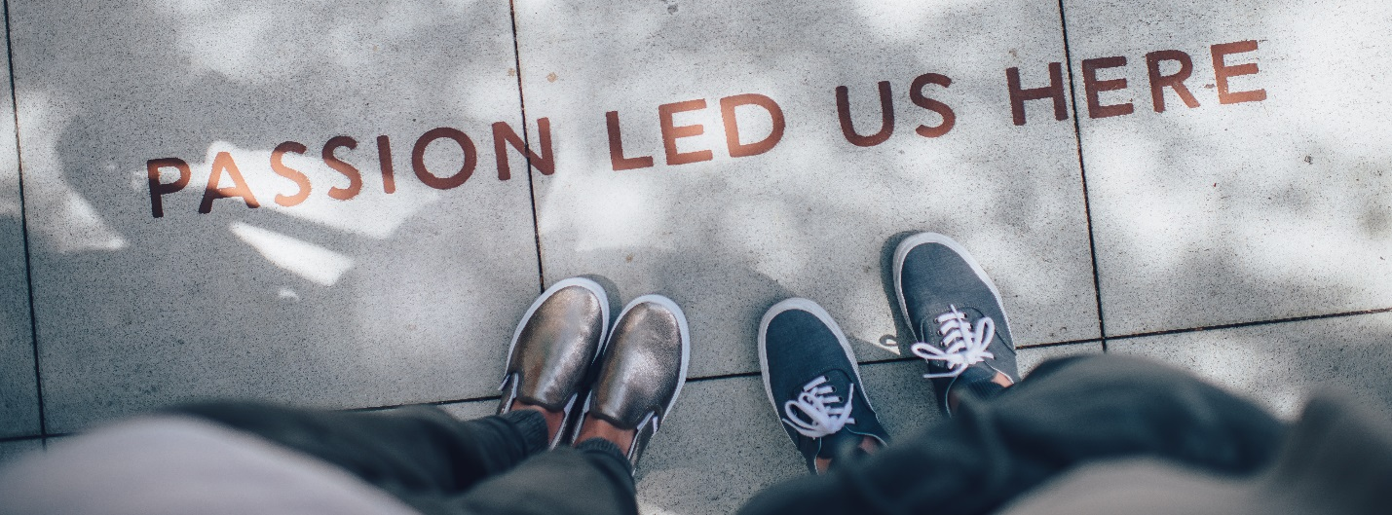
2018 Annual Applied Baccalaureate Conference
Equity, Diversity, & Inclusion in Applied Baccalaureate Degrees:
Rising to the Challenge

Wednesday, November 14th, 2018 ~ 8:30 am-3:30 pm
Spokane Falls Community College
Morning refreshments & lunch included.

Dear Colleagues:

You are cordially invited to the SBCTC’s Annual Applied Baccalaureate Conference. This year’s conference will occur on Wednesday, November 14th at Spokane Falls Community College.

Register Now:
For conference registration, and a preliminary look at conference topics and speakers, click on the following link: http://www.bellevuecollege.edu/baccalaureate-conference/
Agenda will be on the website as it becomes available.

Hotel:
Red Lion River Inn: 700 N. Division St. Spokane, WA 99202
The cutoff date to reserve a room at the state rate is October 23rd.
Booking Link or call the hotel directly at (509) 326-5577 ext.0 and provide them with the group code: STAT1113 for Red Lion River Inn.

