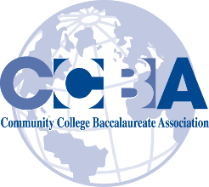
We believe in the power of a baccalaureate degree to change lives for generations.
September 6, 2018
Dear Members and Friends of CCBA
Mark your calendars, the CCBA annual conference will be held February 22-24th, 2019 in New York City. All conference events will be held at the New York Marriott Marquis.
As many of you know, we hold our conference in partnership with the League of Innovation whose conference will immediately follow ours and start late afternoon of the 24th. Our League friends tell us hotel rooms are already going fast so I urge you to book rooms at your earliest convenience. Be sure to get CCBA’s special rate of $289 for their gorgeous rooms. You don’t want you to get shut out of the conference rate or hotel space. Conference registration is now open on the accbd.org website. Early registration pricing ends midnight January 31, 2019.
The Call for Proposals is also open now. This year in addition to our traditional forums we will be including roundtable discussions focused on challenges we all face. We envision 5 to 8 tables each taking an in-depth look at a specific issue, the sharing of experiences and discussions on what has worked and what did not work.
In my speaking with members, there is a strong interest in CCBA offering two additional institutional membership benefits:
- The development of an Exemplary Program Designation for selected community college baccalaureate degrees
- The creation of a Student Honor Recognition program.
If you have an interest, we are looking for individuals to lead the discussions on each of these topics as well as help us in their development.
I hope you are having a great start to this new academic year, and my very best to each of you, Angela

