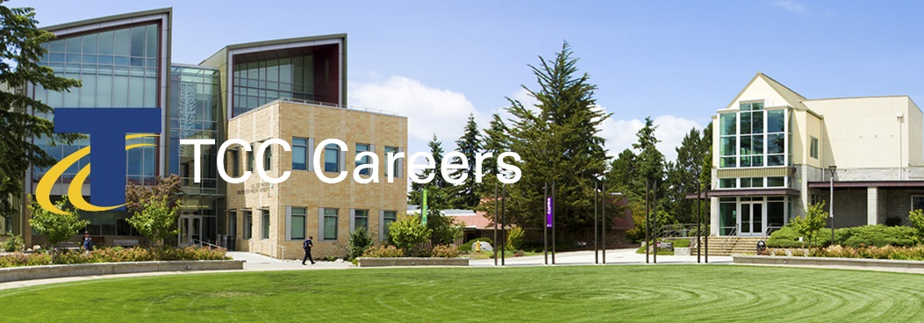 | We invite you to join us and be an active part of a multicultural environment dedicated to academic excellence.  Posting Date: July 18, 2018 Priority Date: August 13, 2018  Announcement: 18-24-AP #MON  Create Learning / Achieve Equity  Engage Community / Embrace Discovery

Program Navigator - Bachelor of Applied Science Programs

Priority Consideration Date: August 13, 2018
Performs a variety of duties to promote the success of baccalaureate degree students. This position works collaboratively to recruit and retain students into the applied baccalaureate program(s) by marketing programs to potential students on campus and in the community. Acts as a main point of contact to prospective applicants. Works with BAS program chair(s) and faculty to support admission processes. Works directly with enrolled students to navigate college services. Works with students and faculty to help prepare for field work/internship/clinical requirements. Responsible for monitoring and reporting of baccalaureate student and program data. Works collaboratively with staff and faculty from Professional-Technical programs, transfer programs, student and academic services, and other campus departments to promote baccalaureate programs. Collaborates with community agencies to promote and support community relationships. Supports BAS faculty and students to achieve success in an environment that values diversity and pluralism. This position reports to the Director of Baccalaureate Programs.

Essential functions
- Identify, develop, and participate in outreach activities (orientations, funding workshops, and individual student appointments) to attract and serve eligible students
- Strategize and implement practices to recruit a diverse student population with a specific focus on equity and access for underrepresented groups.
- Guide students through the application process to include applying for funding and enrolling to the college
- Assist program faculty/staff with admission/selective entry process
- Coordinate with Financial Aid, Workforce, Veteran’s Affair’s, and other funding sources to support eligibility for funding.
- Collaborate on creation/coordination/maintenance of new BAS student orientation activities
- Work with students and faculty to prepare for field work/internship/clinical requirements
- Develop and maintain student records and reports as required by the college and other agencies.
- Provide retention and follow-up services to assist students in career exploration, to ensure student compliance with program policies, and foster student success
- Link students to appropriate campus and community services and resources
- Collect, prepare, and report data via college and agency reporting systems
- Provide excellent customer service to students, potential students, campus partners, and community partners
- Coordinate graduate and employer surveys and/or exit interviews
- Assist in developing marketing materials
- Organize special events
- Create correspondence and other program materials
- Promote all baccalaureate programs to the campus and community.
- Represent the college at meetings and events as needed
- Contribute to the College’s commitment to diversity by fostering a climate of multicultural understanding and appreciation
- Perform related duties as required

Minimum qualifications
- Bachelor’s degree from an accredited college or university, or equivalent work experience in higher education, business, marketing, communications, or related field that align with the essential functions of this position.
- Professional experience working with diverse populations
- Experience presenting information to large and small group settings
- Ability to interpret detailed information, trouble-shoot and problem-solve
- Strong computer skills including Microsoft Word, Excel, PowerPoint, Publisher or similar software

Preferred Qualifications
- Experience in marketing, recruiting, and/or promotional experience, including social media
- Ability to facilitate web meetings
- Experience in a community college setting
- Experience providing assessment and analysis of participants’ needs, skills and goals
- Knowledge of local community resources
- Experience in evaluating and assess data
- Experience in or knowledge of advising and educational planning processes

Conditions of Employment
- Successfully pass a criminal history background check prior to employment.
- Current, valid, unrestricted driver’s license.
The Successful Candidate will Demonstrate
- Commitment to serving the needs of historically underserved populations
- Demonstrated customer service skills; including establishing, building, and maintaining internal/external customer satisfaction.
- Highly professional, ethical, and respectful of confidential data and individuals’ circumstances
- Ability to work independently and as a member of a team
- Excellent verbal, written and interpersonal communication skills
- Technical ability to use computer software programs.
- Ability to take data and produce information
- Skill in assessing and prioritizing multiple tasks, projects and demands.
- Knowledge and understanding of FAFSA and educational loan application process.
- Strong interpersonal skills and demonstrated ability to interact with a diverse population, both internal and external to the college.
- An appreciation of diversity and the benefits of a commitment to cultural awareness and sensitivity in the workplace.
- A commitment to establishing and maintaining positive working relationships with students, colleagues, and staff representing diverse ethnic, cultural, and socioeconomic backgrounds
- Demonstrated ability to work independently and as a member of a team.
- High organizational and problem-solving abilities. Ability to multitask and prioritize a heavy workload.
- Commitment to serving the needs of historically underserved populations with barriers to education and employment.

Application Materials & Procedure
Complete application packages must include the following.
- Tacoma Community College online application.
- Resume & cover letter describing how your educational background and experience align with the responsibilities and qualifications.
- Copies of transcripts for all colleges and universities attended.
- Tacoma Community College is committed to creating and supporting a multi-cultural climate that welcomes, fosters, respects, and celebrates diversity. Please attach a statement (maximum two pages) describing your experiences with other cultures and communities, your level of cultural self-awareness and how you have integrated both experience and self-awareness into your living/working environment.

Terms of Employment
This is a full-time exempt position contracted on an annual basis. The salary range for this position is $49,419 – 52,000 DOE/DOQ. The salary will be prorated to reflect the actual number of contract days worked in the remainder of the year. Flexibility is required to meet the needs of the department. Schedule may include early mornings, evenings and occasional weekend availability. Degrees must be from accredited colleges or universities recognized by the U.S. Department of Education and verified by National Student Clearinghouse.

Tacoma Community College values diversity and is an Equal Opportunity Employer and Educator
Tacoma Community College provides equal opportunity in education and employment and does not discriminate on the basis of race, color, national origin, age, disability, genetic information, sex, sexual orientation, marital status, creed, religion, or status as a veteran of war. Prohibited sex discrimination includes sexual harassment (unwelcome sexual conduct of various types). Provides reasonable accommodations for qualified students, employees, and applicants with disabilities in accordance with the Americans with Disabilities Act and Federal Rehabilitation Act. The following persons have been designated to handle inquiries regarding non-discrimination policies: Bill Saraceno, Title II and Title IX, 253-566-5050; Dolores Haugen, Section 504 Officer, 253-566-6090. Tacoma Community College is a smoke-free/drug free environment. This recruitment announcement does not reflect the entire job description and can be changed and or modified without notice.
Tacoma Community College 6501 S 19th St Bldg. 14, Tacoma WA 98466 www.tacomacc.edu/careers

