Welcome to

TEMPORARY PARKING PERMIT (#330131)
PLACE ON DASH OF VEHICLE
VALID DATE(S): | 10/10/2017
AUTHORIZED PERSON OR EVENT: | SBCTC Baccalaureate Leadership Council
EMPLOYEE SPONSOR: | Shanon Ehmke-reedy
Second Hand Dissemination of this document is not authorized without prior consent of the BC Department of Public Safety

THIS VEHICLE IS AUTHORIZED TO PARK IN ANY BELLEVUE COLLEGE MAIN CAMPUS LOT ON THE DATE(S) SPECIFIED.
QUESTIONS? VISIT THE PUBLIC SAFETY DEPARTMENT IN K100 OR CALL 425-564-2400.
-------------------------------------------------------------------- FOLD HERE --------------------------------------------------------------------
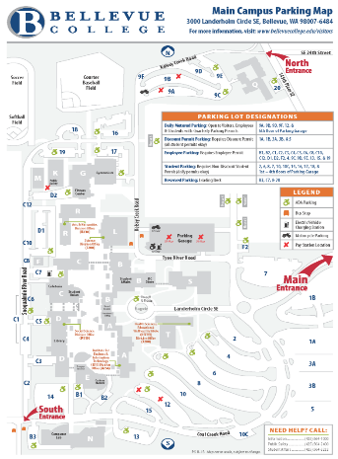
BELLEVUE COLLEGE MAIN CAMPUS PARKING LOT MAP

Campus Address:
Main Campus is located at:
3000 Landerholm Circle SE, Bellevue, WA 98007-6484.

Directions to Main Entrance:

From Seattle:
Follow I-90 eastbound. Take exit 11A and follow the signs to 156th Ave. S.E. The ramp will merge you onto So. 150th heading North. Proceed through the first stoplight (S.E. Eastgate Way) and get in the left lane. At the second stoplight ( S.E.28th St.) turn left into BC's main entrance.

From Issaquah:
Take I-90 westbound to Exit 11. After exiting, follow the signs for 156th Ave. SE. At the stoplight, turn left onto Eastgate Way. Move into the right lane and turn right at 150th Ave. SE. Get in the left lane and proceed up the hill. At the stoplight (S.E.28th St.) turn left into BC's main entrance.

