Work$ Ready
Program Information

WHAT
Work$ Ready is a free, online job readiness training created in response to the unprecedented need to help job seekers reenter the workforce. Classes are taught by experienced workforce instructors live via a video-conferencing tool. The curriculum includes key topics such as professional presence, resume writing and interview practice as well as soft skills needed to land and keep a job. The curriculum includes the following:

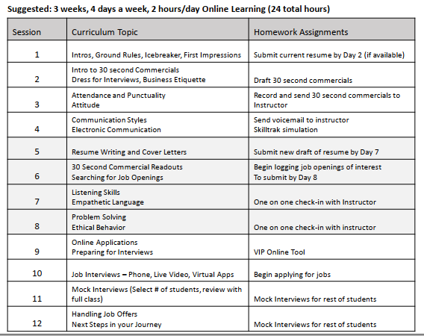

WHY
During this time of unprecedented unemployment, Work$ Ready is a way for the YWCA to lend our expertise to help people get back to work by boosting their confidence and job readiness skills.

WHO
Work$ Ready is available to any individual free of charge.

In order to participate, prospective students need to commit to full participation, including attending all online classes and completing assignments. Participants will also need access to a computer, laptop tablet or smartphone and internet connectivity. If someone who wants to participate doesn’t have a suitable device and/or Wi-Fi, YWCA may be able to help address that need.

WHEN
YWCA will begin offering this free, online, 3 week class on May 4th. Classes will run 4 days per week for 2 hours per day.

WHERE
All Work$ Ready session will be online, facilitated live by an experienced instructor.

HOW
To learn more about Work$ Ready and to request to participate, contact YWCA by phone at 206.823.5753 or 253.736.2301

