Sign up for Secure Access Washington (SAW)

- Create a SAW Account

- Add a New Service

- Adaptive Authentication Enrollment

Create a SAW Account

- Go to the Secure Access Washington (SAW) website https://secureaccess.wa.gov/dshs/ejas/ to create your User ID and password. Click Create One.

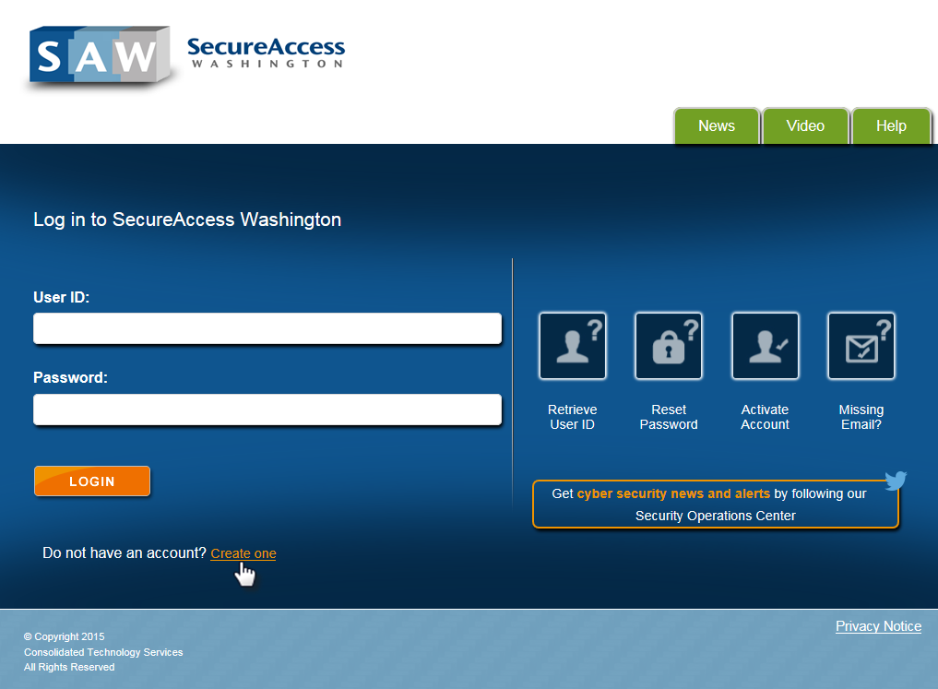

- Click START.

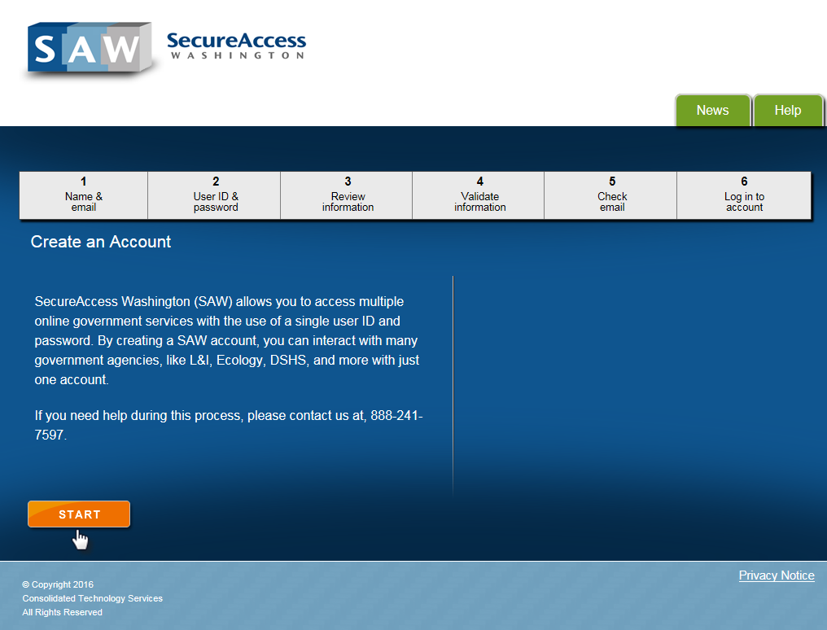

- Update the following fields and click NEXT.

- Make sure to use your legal name and work email address.

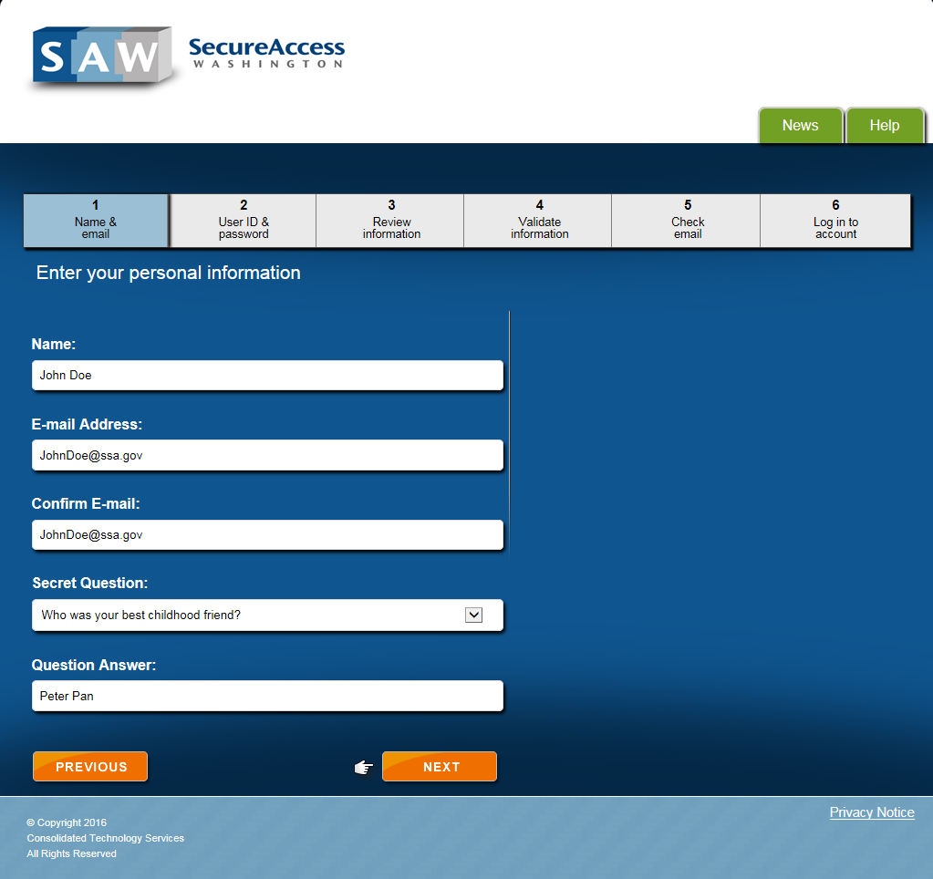

- Update the required fields and click NEXT.

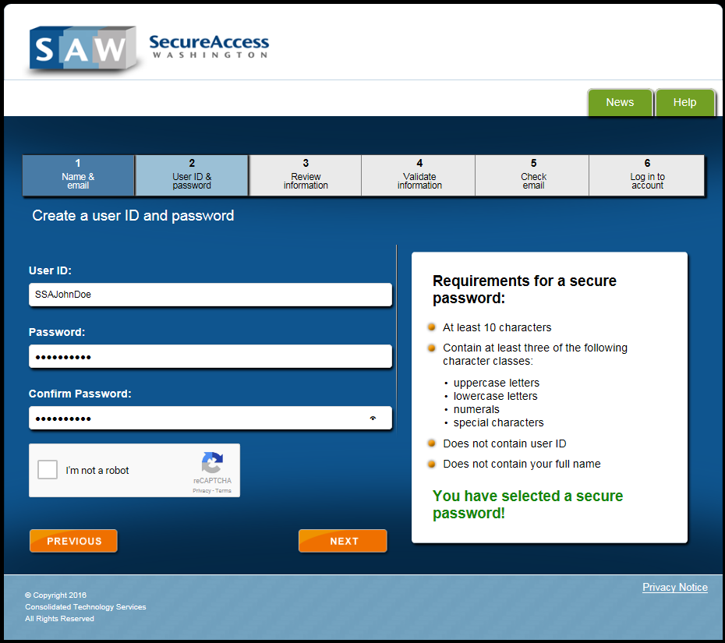

- Review the information and click NEXT to continue.

- If any of the information showing is incorrect, click PREVIOUS to go back and make any needed corrections.

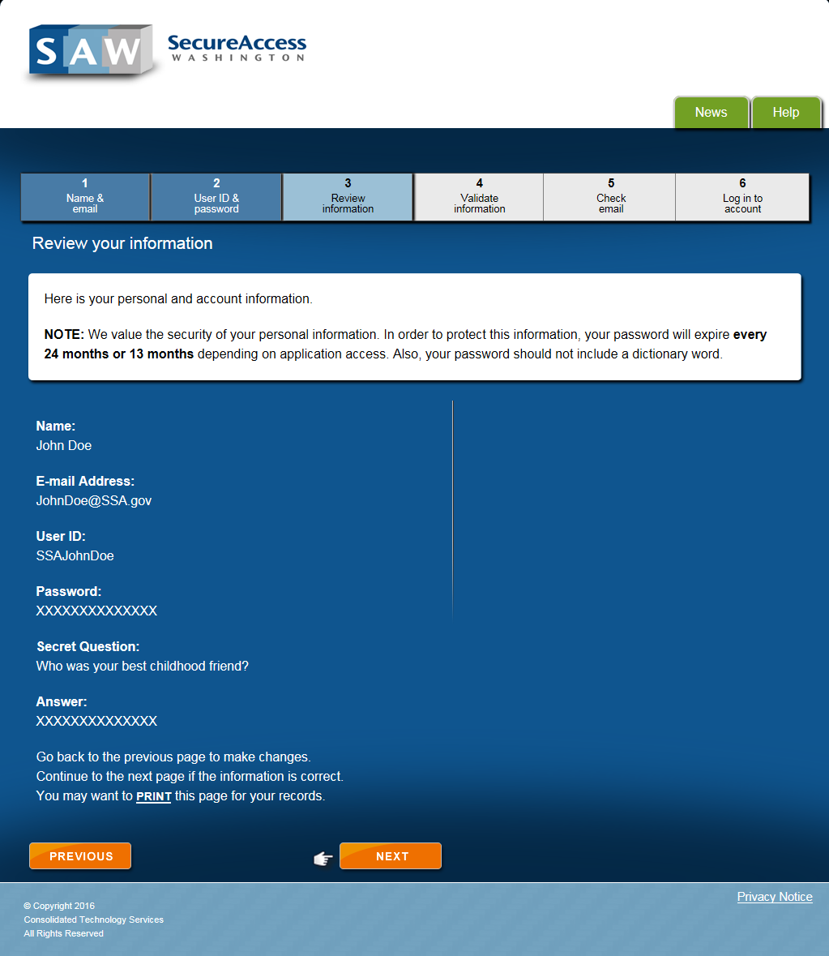

Check your email - To complete the registration process, follow the instructions contained in the email you’ll receive from SecureAccess Washington.

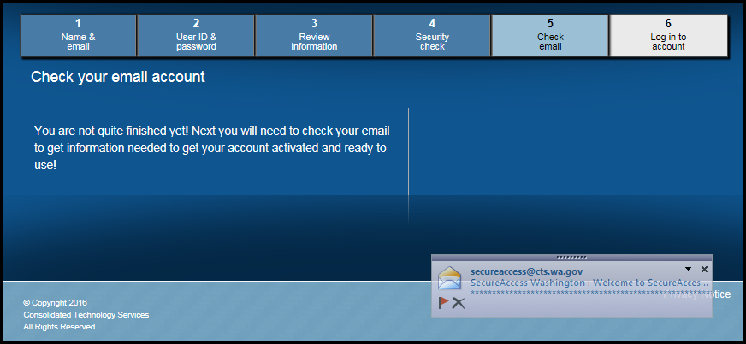

- Click the link to complete the activation.

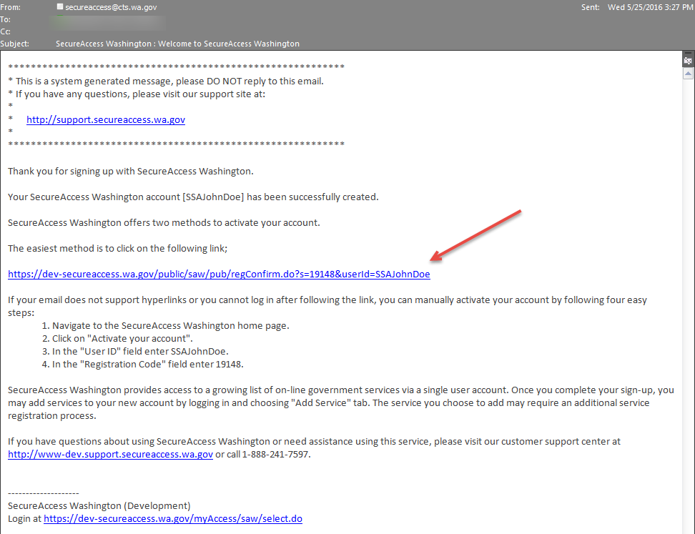

Add a New Service

- Login by entering your user ID, password and clicking LOGIN.

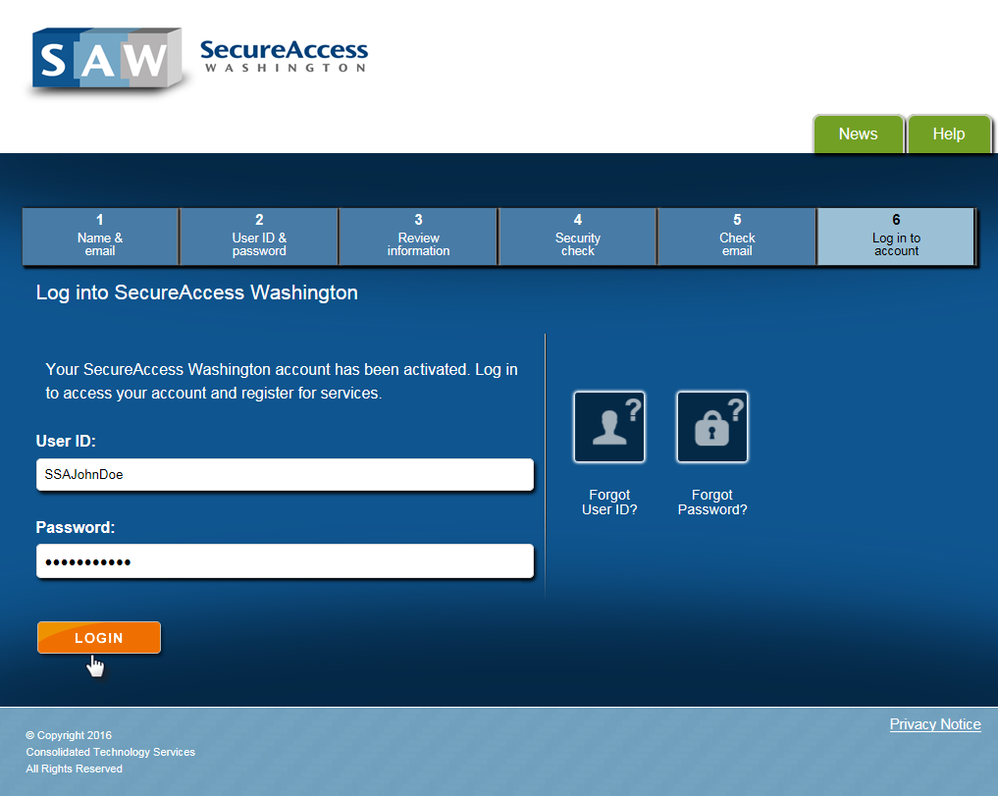

- To add a new service to the My Services list, click the Add A New Service tab.

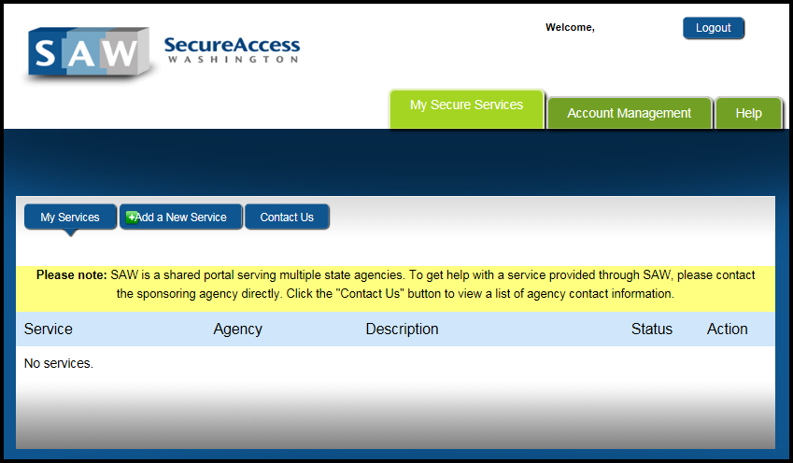

- Enter Service Code # 12152016 (for eJAS Production) and click APPLY.

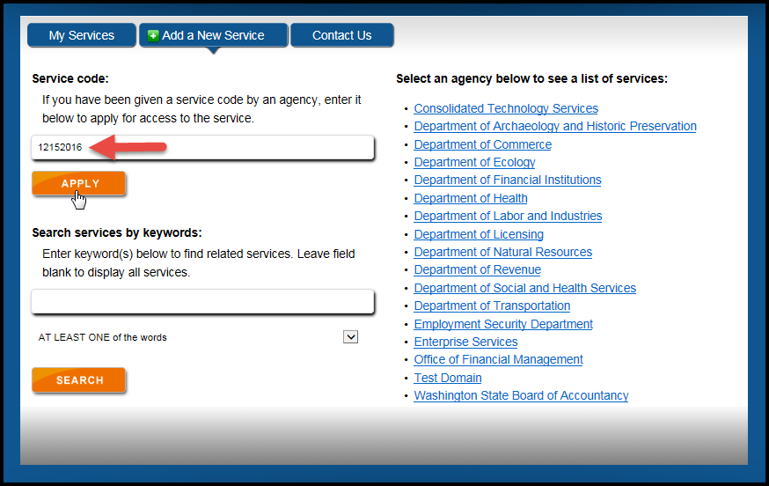

- A Service Registration Successful message displays and a confirmation email sent.

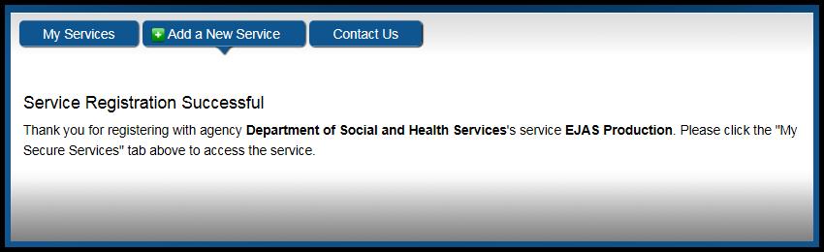

- Click the My Services tab to access the eJAS Production site.

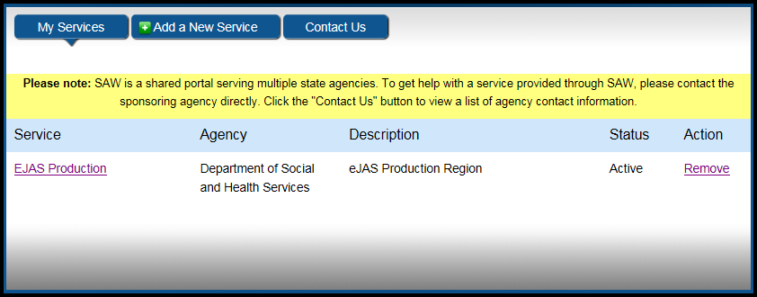

Adaptive Authentication Enrollment

- Adaptive Authentication Enrollment and verification allows the system to verify who you really are even when signing in from computers not recognized.

Click CONTINUE.

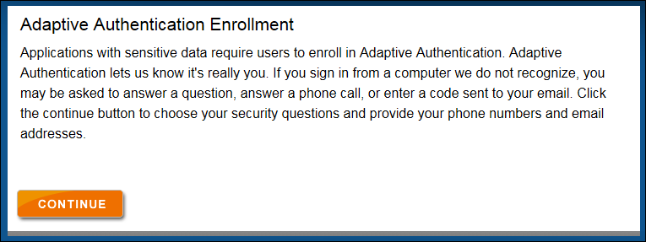

- Enter your primary work email address and click CONTINUE.

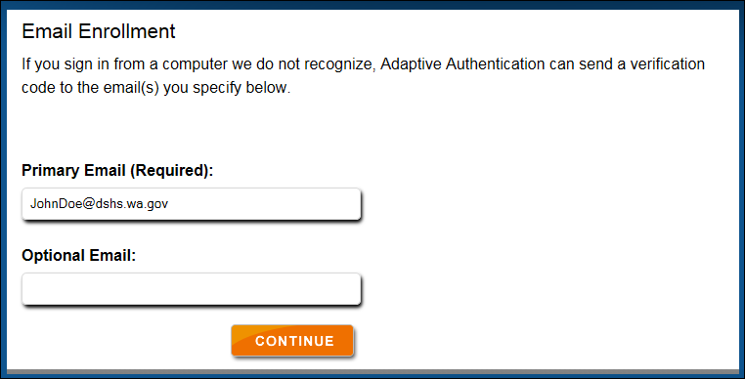

- Enter your primary work phone information and click CONTINUE.

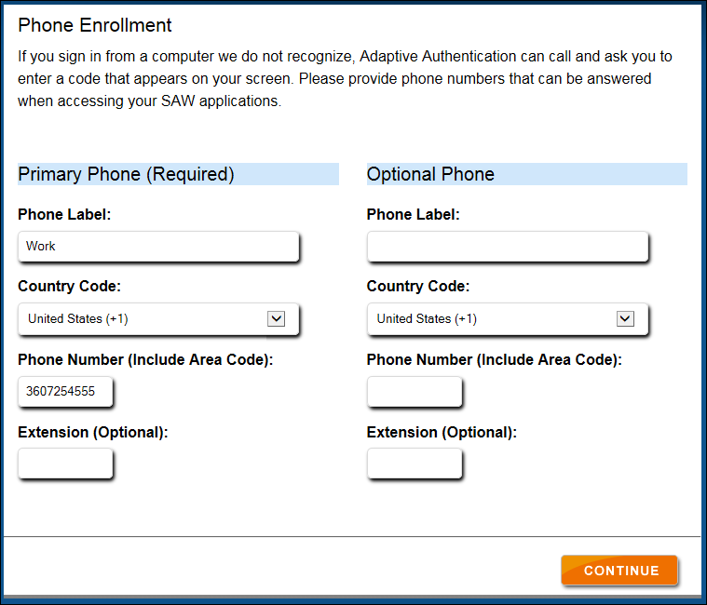

- Select your challenge questions and provide answers. Then click CONTINUE.

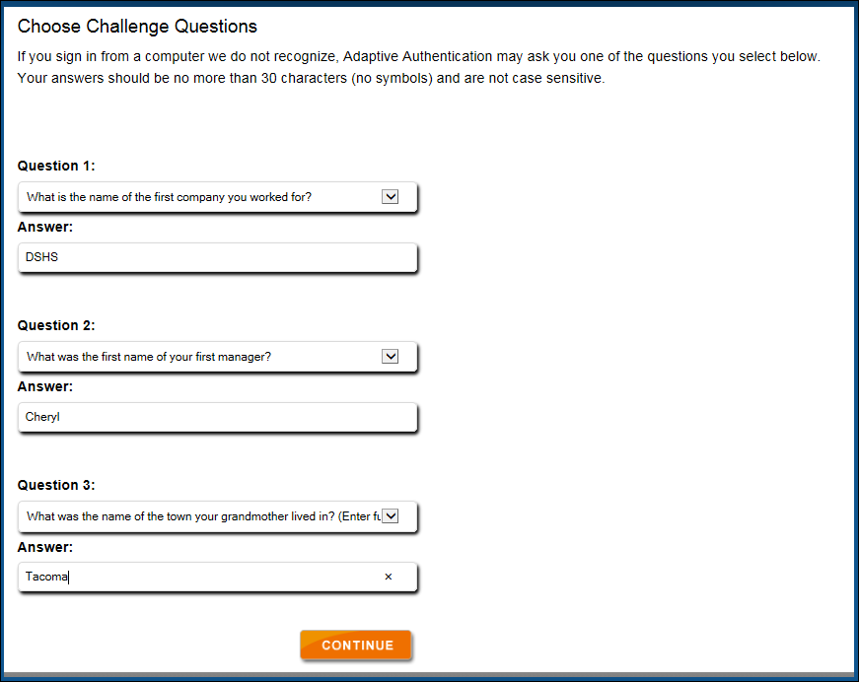

- Review the information entered and finalize by clicking SUBMIT.

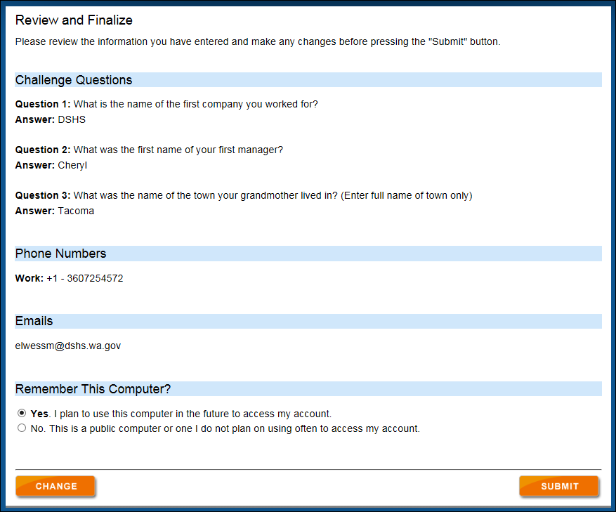

- Once the Adaptive Authentication enrollment is complete, you will then be directed to your requested service.

