Navigating with a Screen Reader Basics

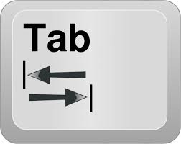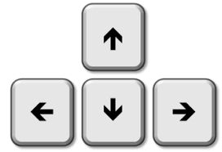

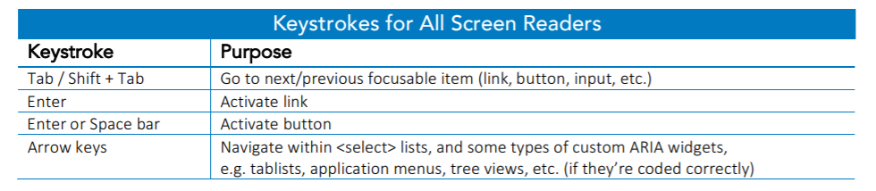

Use the Tab key to navigate through all the interactive items. Pressing Tab generally moves you to the next interactive element on the screen. In general, tab is a quick way to get around but you'll probably skip over paragraphs of text in the process.

The arrow keys will read line by line, reading everything on the page at your navigation pace. The arrow keys represent the smallest movement forwards or backwards that you can make. If you're using the arrow keys, you're not going to skip over anything on the screen, in most cases, but there may be some areas that you can't get to just by using the arrow keys.

Navigating the Elements List in NVDA

To move between the Types, (tab, if needed, to get into the Types List) use Arrow keys.
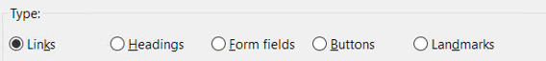

Once you land on the Type you want, use the Tab to get down into the list. Then use arrow keys.
Then hit Enter to select what you want to open.
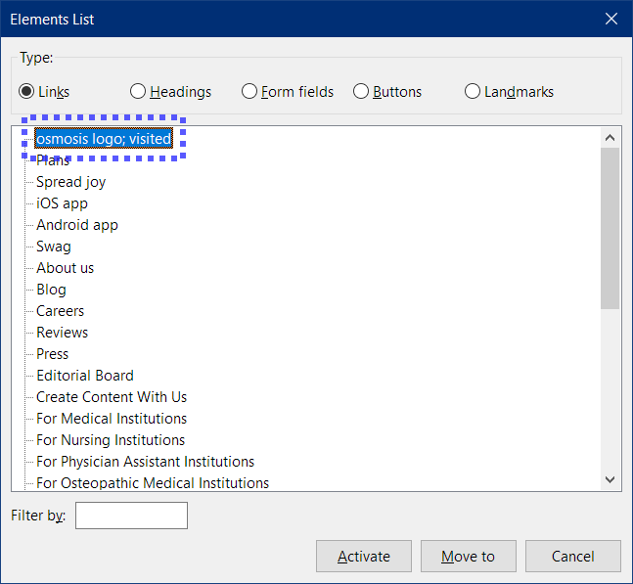

Basic NVDA Commands
NVDA
Task | Command
Start NVDA | Ctrl + Alt + N
Shut down | Insert + Q
Navigate Text (navigates all elements) | Up and Down arrows
Read next item | Down arrow
Continuous Text Reading of P. (Otherwise, it is line by line) | Ctrl + down arrow
Navigate Active Elements (form fields, checkboxes, etc.) | Tab
Show Elements list | Insert + F7
Headings | H
Tables | T
Navigate Table Cells | Arrow keys
Form Quick Key | F
Next Image | G
Keyboard help | NVDA + 1
Stop Speech | Control

