Important Visual Setting in NVDA
This setting helps give you the blue box and red box to help you see where your focus has landed and it helps navigation a little bit better for us who are sighted testers. This used to be an add-on but NVDA added as one of their settings which is really nice.

Turn on NVDA, right-click on the NVDA icon 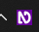 down in your Notification area. Go to Preferences and then Settings.
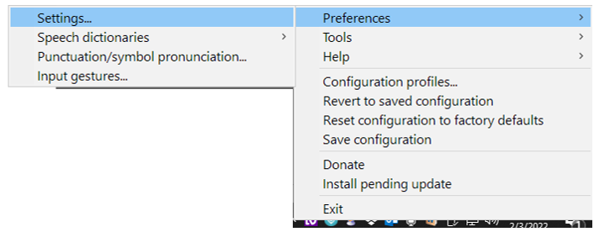

Navigate to Vision and check all boxes under Visual Highlight and Options if you have not already set them.
